Team Name:

Geominers

Project Title:

GRAFTS

Geologic Research Automated File Transfer System

Team Members:

Logan Barclay

Joe Bell

Patrick Cullings

Benjamin Hetz

Chris McLellen

Aaron Whetzel

| **Last Name** | **First Name** | **GitHub User Name** | **Scrum Role** |
| --- | --- | --- | --- |
| Barclay | Logan | loganbarclay | Developer |
| Bell | Joe | joeb-bsu | Product Owner |
| Cullings | Patrick | pcullings | Developer |
| Hetz | Benjamin | BenjaminHetz | Developer |
| McLellen | Chris | chrismclellen | Scrum Master |
| Whetzel | Aaron | awhetzel | Developer |

Sponsor Information:

Sponsor #1

Lab For Echohhydrology and Alternative Futuring

Dr. Alejandro N. Flores

Phone: 208-426-2903

[lejoflores@boisestate.edu](mailto:lejoflores@boisestate.edu)



Sponsor #2

Adapt Data Flow Optimizations Lab

Dr. Cathie Olschanowsky

Phone: 208-426-5730

[catherineolschan@boisestate.edu](mailto:catherineolschan@boisestate.edu)

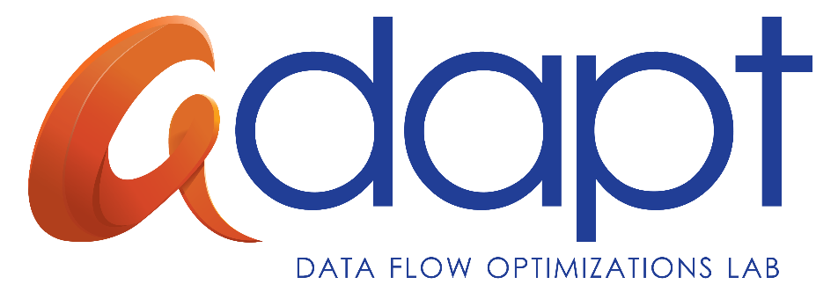

Project Abstract:

NOAA and NASA provide access to time-series satellite observations and derived estimates of geophysical parameters for research and operational purposes. This data is organized and saved in specific servers, and will show up periodically on specified intervals. The location and organization of the files are well known. Leaf researchers usually only need specific subsets of the original data, and find that manually retrieving the data is time consuming and error prone. Moreover, because of the large volumes of data retrieved from the observational systems, this data can only be accessed through web services for a relatively short period of time. After some period, this data is typically written to tape and must be obtained via special request.

The GRAFTS project provides a service that can be deployed locally by a researcher. The researcher can use this project’s web application to instruct the server to periodically download relevant data from the near past. Using the GRAFTS web application, the researcher will then be able to quickly discover which files are present or absent from the local data collection that will be permanently available for them to query. Additionally, this project provides a sub-setting service that allows the researcher to subset a file or set of files and retrieve only the specific data they are targeting.